**RENESENG 4th Year Deliverables**

User Guide for the Roadmap Visualisation of Supply Chains

March 2018

Dr. Nathanial Cooper

Marie Curie ITN Experienced Researcher

ER 3.2

Imperial College London, Chemical Engineering, London

User Guide for the Roadmap Visualisation of Supply Chains

As a prerequisite, QGIS must be downloaded and installed. QGIS is available from the qgis.org website at <https://www.qgis.org/en/site/forusers/download.html>. It is recommended to select either the “Latest Release” or “Long Term Release” rather than the OSGeo4W version, as the OSGeo4W version is far more complex, more than needed.

1) To use the algorithm, a new Project must be created, and the grid shapefile must be added to the project. To do this, open QGIS, and select New in the upper left

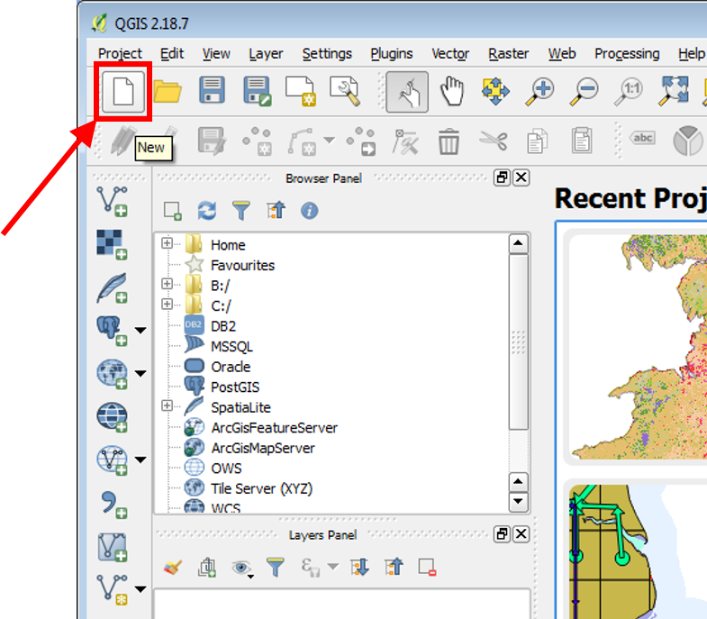

2) To add the grid shapefile, select the *Add Vector Layer* button from the left side panel

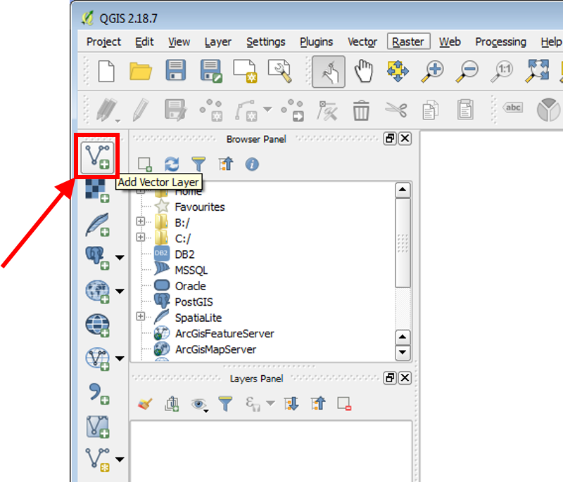

3) Select *Browse* in the “Add vector layer” window that appears

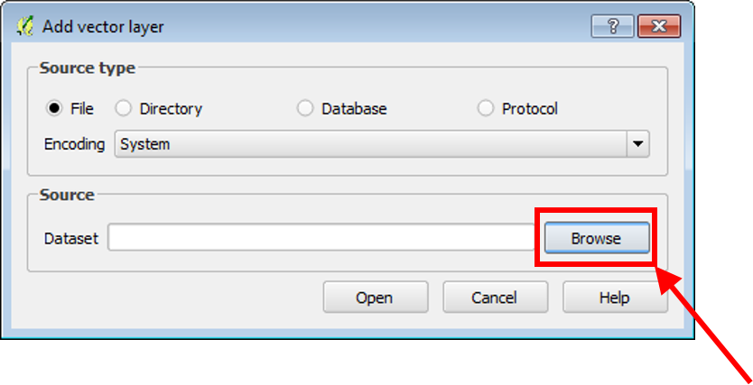

4) Find the location of the grid shapefile and open it using the standard dialogue.

5) Now select *Open* in the “Add vector layer” window

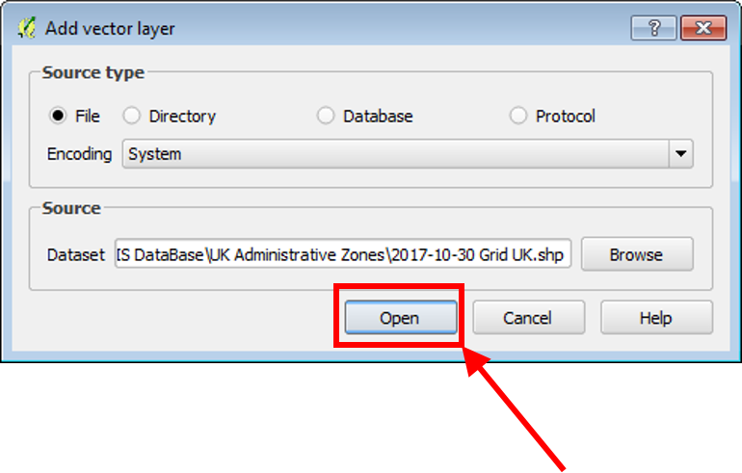

6) Now that the shapefile has been inserted, we can prepare to include the algorithm. To do this, activate the Processing Toolbox by selecting the *Processing* top menu, and choosing *Toolbox* from the dropdown menu

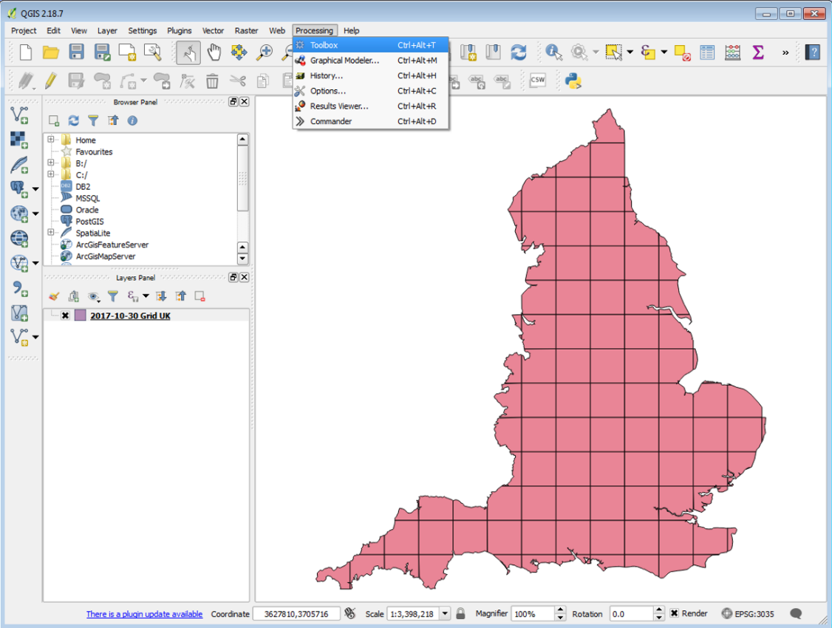

-------------

From here, 2 paths can be taken to get the code – either copy & paste the code or download it from GitHub and add the script.

Copy and Paste

7a) Expand *Scripts*, then *Tools*, then select *Create new script* under the “Processing Toolbox” window

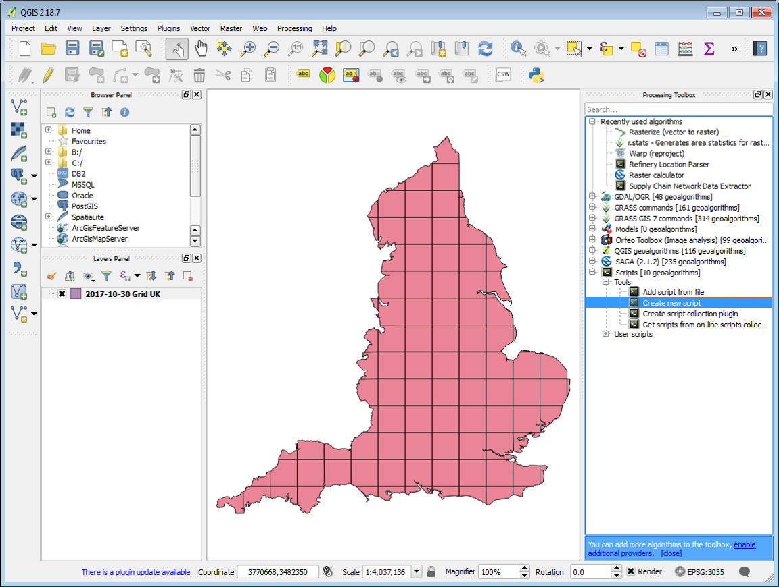

7b) Find the source code on GitHub (currently <https://github.com/nathanialcooper/Biomass-Supply-Chain-Roadmapping/blob/master/refineryLocationParse.py>). Copy and paste just the code into the new script window

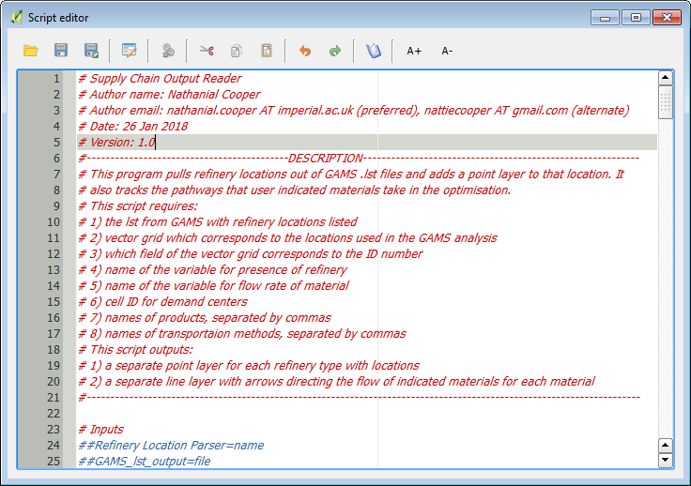

Download

7a) In a web browser, navigate to the GitHub page for the project

(<https://github.com/nathanialcooper/Biomass-Supply-Chain-Roadmapping>) and select the *Clone or download* button, and choose to *Download ZIP*. Unzip the zip to wherever you would like.

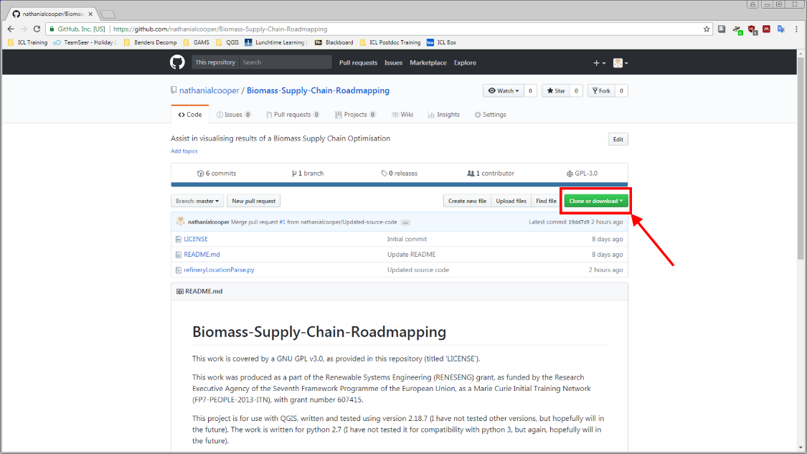

7b) In QGIS, expand *Scripts*, then *Tools*, then select *Add script from file* under the “Processing Toolbox” window

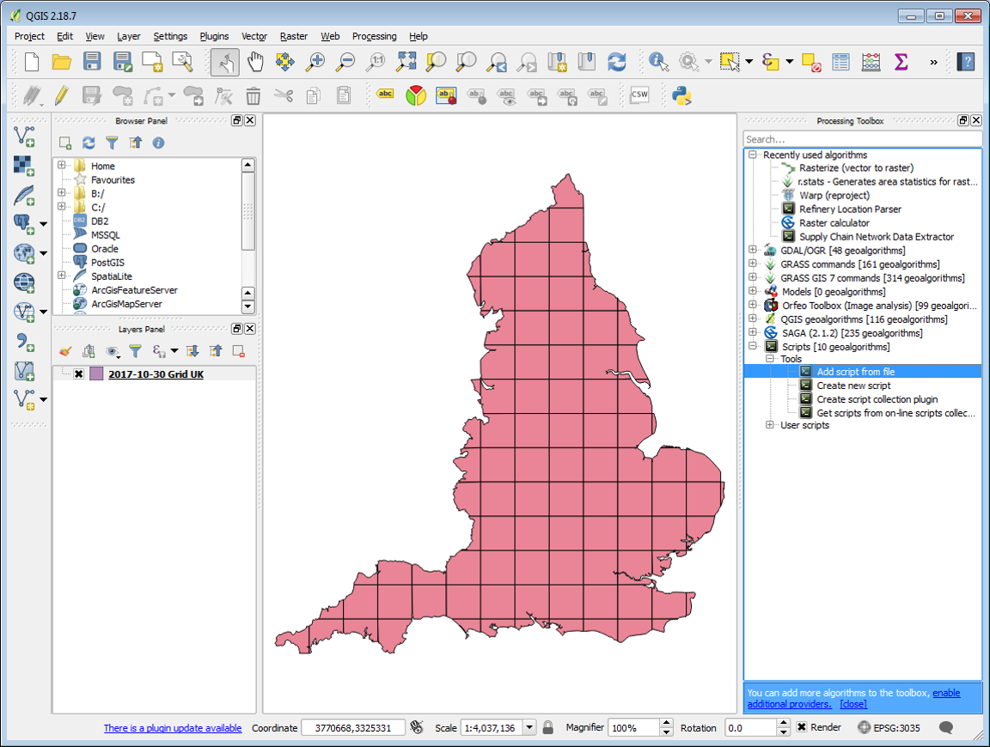

7c) Navigate to the script from the ZIP file and open it.

-----------

8) Now it is possible to run the algorithm. To run it, select the *Run Algorithm* button that looks like gears in the “Script Editor” window

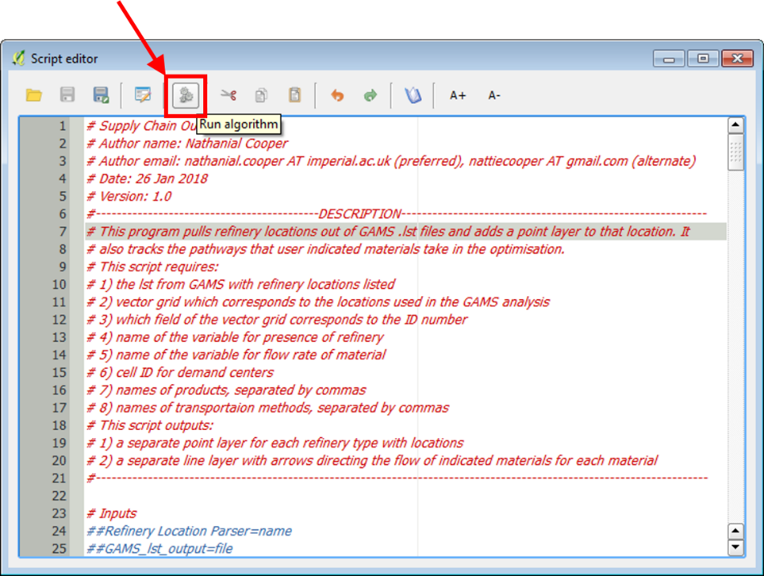

9) Enter the information requested by the algorithm dialogue, “Refinery Location Parser”. [NB: The GAMS lst output is listed as optional – it is not]. To select the location of the GAMS lst output, click on the ellipses button adjacent to text box

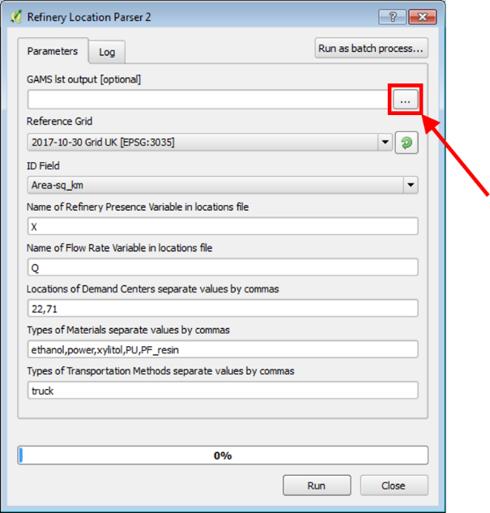

9) If it is not already selected, choose the grid shapefile from the *Reference Grid* dropdown

10) Select the field of the shapefile that has the grid cell ID numbers as its content from the *ID Field* dropdown

11) Enter the name of the variable used to identify the presence of a refinery in the GAMS file

12) Enter the name of the variable used to identify the flow between cells in the GAMS file in the available text box

13) Enter the grid cell ID numbers corresponding to the locations of the Demand Centres, separated by commas with no spaces in the available text box

14) Enter the names of the materials whose flow should be tracked and graphed as they appear in the GAMS file, separated by commas with no spaces in the available text box

15) Enter the names of the transport methods whose flow should be tracked and graphed as they appear in the GAMS file, separated by commas with no spaces in the available text box

16) Click the *Run* button at the bottom of the dialogue box

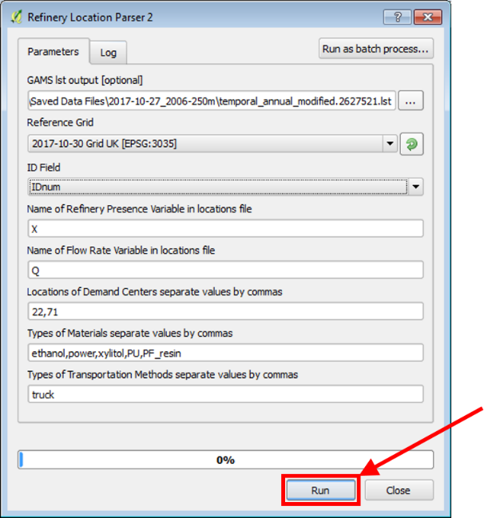

17) Close the dialogue after it has finished running, if it is still open (if it closes itself, this is fine)

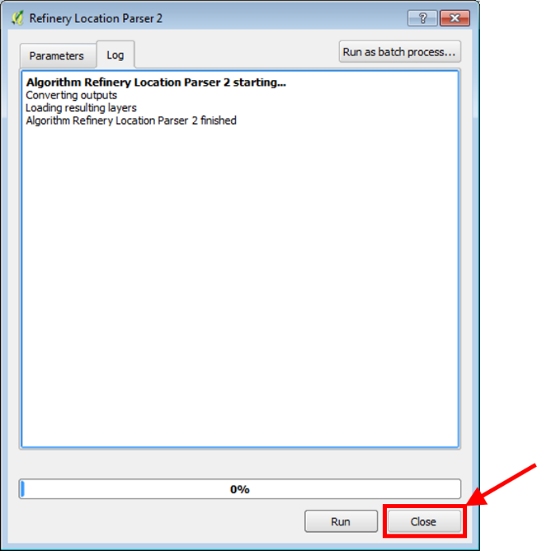

18) All generated layers are now listed under the “Layers Panel” on the left hand side of QGIS. Visibility can be toggled using the x next to each layer name

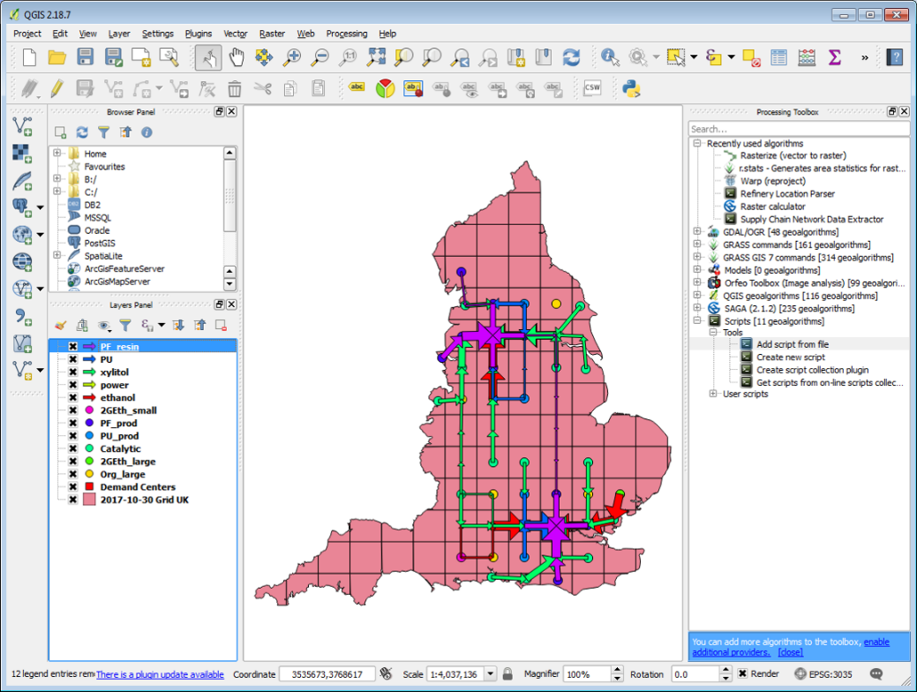

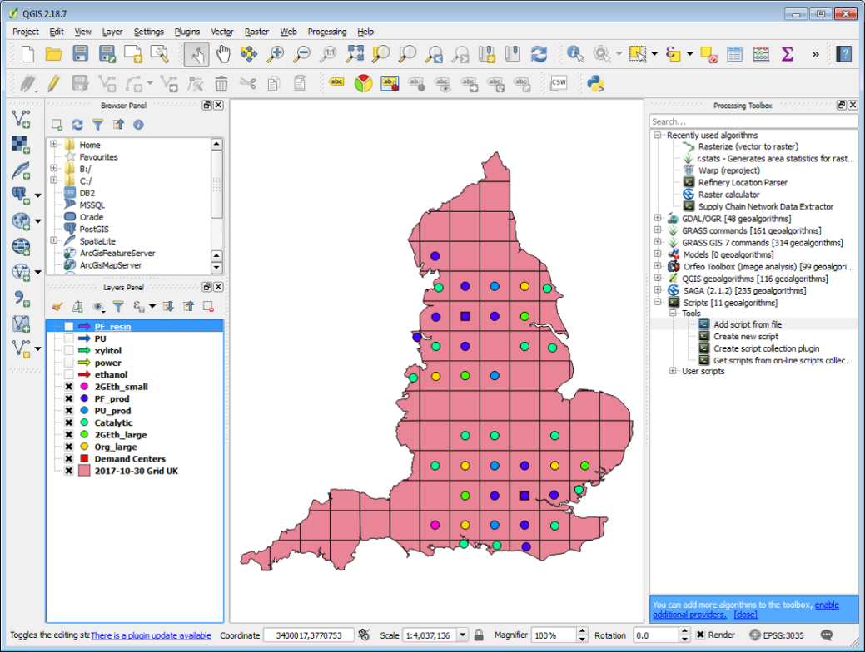

19) These layers can now be saved for future reference. Right click on the layer name you wish to save

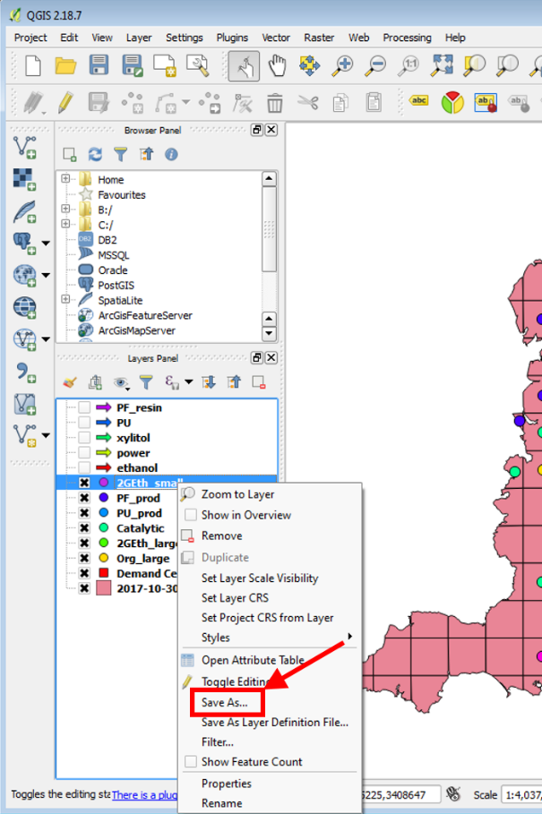

20) In the “Save vector layer as…” dialogue, select the *Browse* button to designate a save location

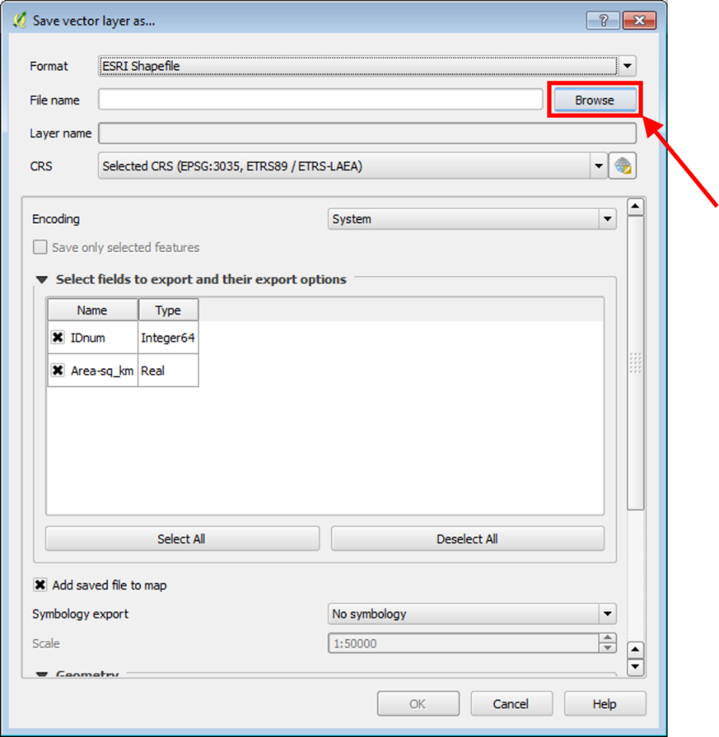

21) Uncheck the *Add saved file to map* option

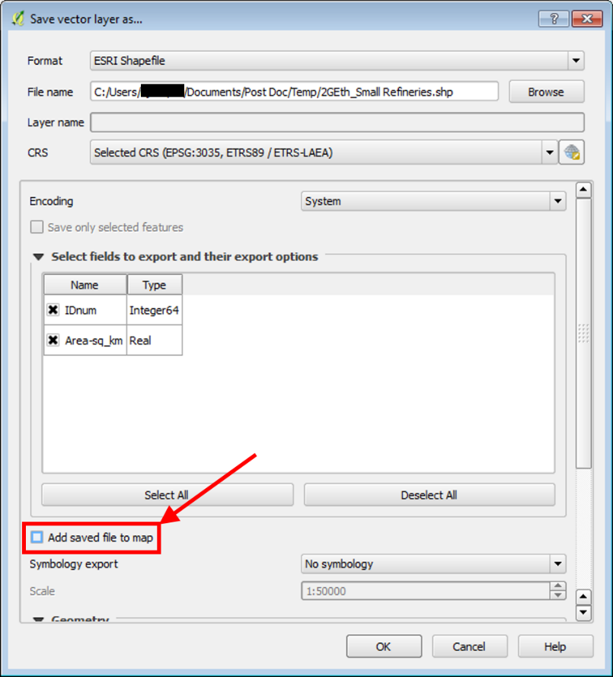

22) Click *OK* to save the file

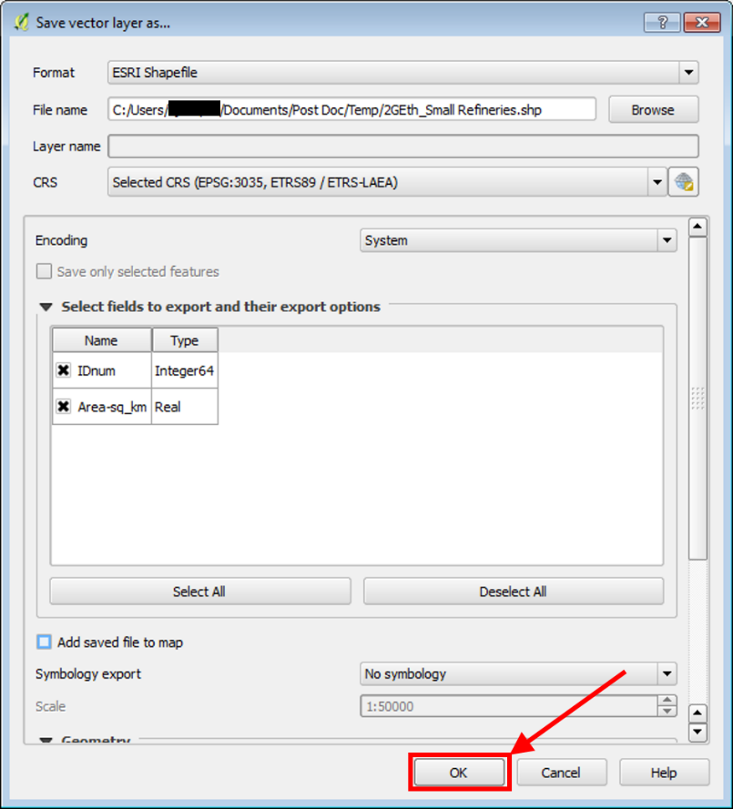

23a) In addition to saving the layers, other methods of creating useful images from the layers may be employed, such as saving the layers and grid as an image (*Project* tab >> *Save as Image…*)

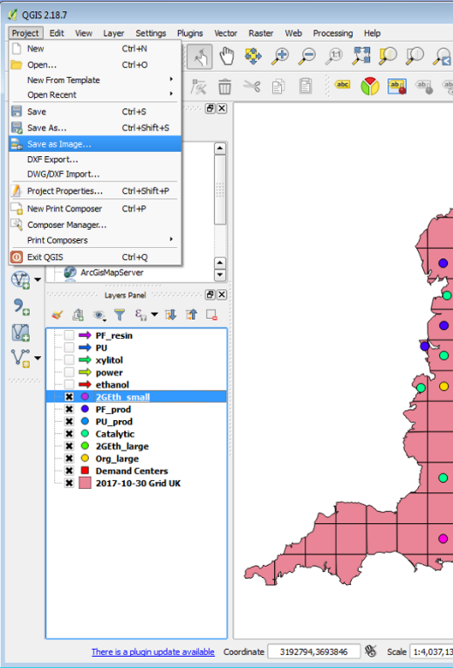

23b) Or by creating a map using Print Composer (*Project* tab >> *New Print Composer*). A tutorial on this can be found at <http://www.qgistutorials.com/en/docs/making_a_map.html>

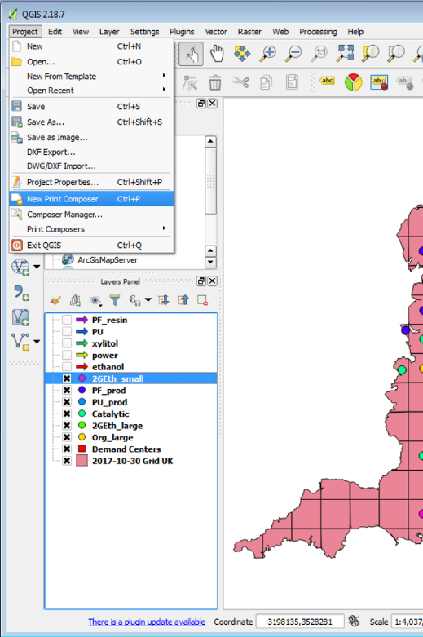

23c) Or simply a screenshot